___________________________________________________________________________

*Faculty of Information Technology and Engineering*

*Electrical Circuit Lab*

|  |  |
| --- | --- |
| Students ID: 202110795, 202112300, 202110451 | Students Name: Sama Haitham Sammar, Arein Zaid Alkilani, Yara Jehad Rabaya |
| Experiment #: 7 | Experiment Name: Steady State Response and Phase Angle of 1St Order Systems |
| Section: 3 | Supervisor Name: Dr Amjad Abu Jazar |
| Date: 30 May 2024 | Day: Thursday |

***Objective:***

1. To study the voltage-current and impedance relationships of a first order system.
2. To study phase angle measurement techniques and its relationship with the frequency.
3. To study the relationship between time-shift and phase shift.

***Apparatus Required:***

* Digital Multimeter.
* Signal Generator.
* Oscilloscope.
* Components (Resistors, Capacitors, Inductors, Cables and Breadboard).

***Theory and Background:***

The voltage and current of a first order system excited by a sinusoidal signal can be represented by two phasors that are not in phase. In this experiment we will study the steady-state response and the phase angle between voltage and current of a first order system.

To study the voltage current relationships of a first order system let’s try to find VR in figure 1.

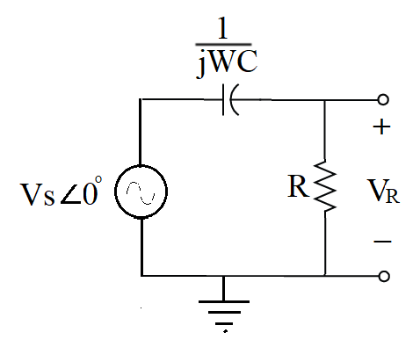

Figure 1

Apply voltage divider to find the voltage across R:

.

The phase deferent between voltage and current for this arrangement is

* **Phasor**

The complex voltage or current at a given frequency is characterized by only two parameters, amplitude and phase angle. For example, the complex voltage  can be exactly defined if Vm and θ are known. Therefore, for any linear circuit operating in the sinusoidal steady state at a single frequency Ѡ, every current or voltage may be characterized completely by its amplitude and phase angle; and their complex representation will contain the same factor .

Thus, it is possible to simplify the complex representation by omitting the factor . Also, additional time and effort may be saved if these complex quantities are written in polar form.

Let us define impedance **Z** as the ratio of the phasor voltage to phasor current. Impedance is a complex quantity having dimensions of ohms. Think of an inductor **L** as being represented in the time-domain by its inductance L and in the frequency domain by its impedance **j Ѡ L**. The same can be said about **C** and **1/ j Ѡ L**. Also, note that the impedance of an inductor and capacitor are functions of frequency.

**Table (1):**

|  |  |  |  |
| --- | --- | --- | --- |
| **Component** | **Voltage** | **Phase** | **Impedance** |
| **R** |  | In phase |  |
| **C** |  | Lead 90 |  |
| **L** |  | Lag 90 |  |

* **Phase Measurement**

Phase comparison of two signals of the same frequency can be made using the dual trace feature of the scopes in the lab. To make the comparison, proceed as follows:

* Use the Oscilloscope prop to find the time difference between the two waves (∆t) i.e.: two successive peak or two successive zeroes.
* Use this equation to convert the time delay to degree

Where f is the frequency of the signals.

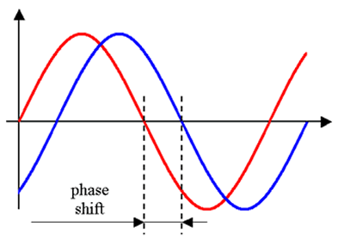

Figure 2

***Experiment Procedure:***

* 1. **Connect the circuit shown below.**

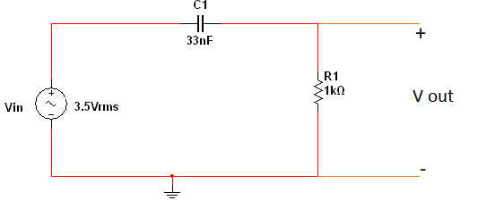

Figure 3

* 1. **Find the RMS voltage across the source, resistor and capacitor for each of the following frequencies (Hz): 100, 500, 1K, 2K, and 5K, 10K,20K,30k.**
  2. **Measure the phase between the source voltage and the circuit current for each of the frequencies listed in step 2.**
  3. **Tabulate your result in the Table (2):**

**Table (2):**

|  |  |  |  |  |  |  |  |  |
| --- | --- | --- | --- | --- | --- | --- | --- | --- |
| **Freq.**  **(Hz)** | **|Vin|**  **By Multisim** | **|Vin|**  **on Lab** | **|VR1|**  **By Multisim** | **|VR1|**  **on Lab** | **|VC1|**  **By Multisim** | **|VC1|**  **on Lab** | **Ө**  **By Multisim** | **Ө**  **on Lab** |
| **500** | 3.5 V | 3.77V | **362m** | 0.41V | **3.5V** | 3.74 V | **87.5** | 81 |
| **1k** | 3.5 V | 3.8V | **712m** | 0.88V | **3.42V** | 3.60 V | **85.4** | 73.4 |
| **2k** | 3.5 V | 3.7V | **1.43V** | 1.61V | **3.23V** | 3.42 V | **72.7** | 65.1 |
| **5k** | 3.5 V | 3.59V | **2.52V** | 2.66V | **2.43V** | 2.35 V | **56.16** | 40.4 |
| **10k** | 3.5 V | 2.98V | **3.15V** | 2.70V | **1.52V** | 1.15 V | **31.46** | 24.7 |
| **20k** | 3.5 V | 2.3V | **3.4V** | 2.20V | **817 mV** | 0.40 V | **12.6** | 12.7 |
| **30k** | 3.5 V | 1.93V | **3.46V** | 1.90V | **553mV** | 0.13 V | **8.1** | 8.321 |

Vout leads Vin in all frequancy

By Multisim

**500K:**

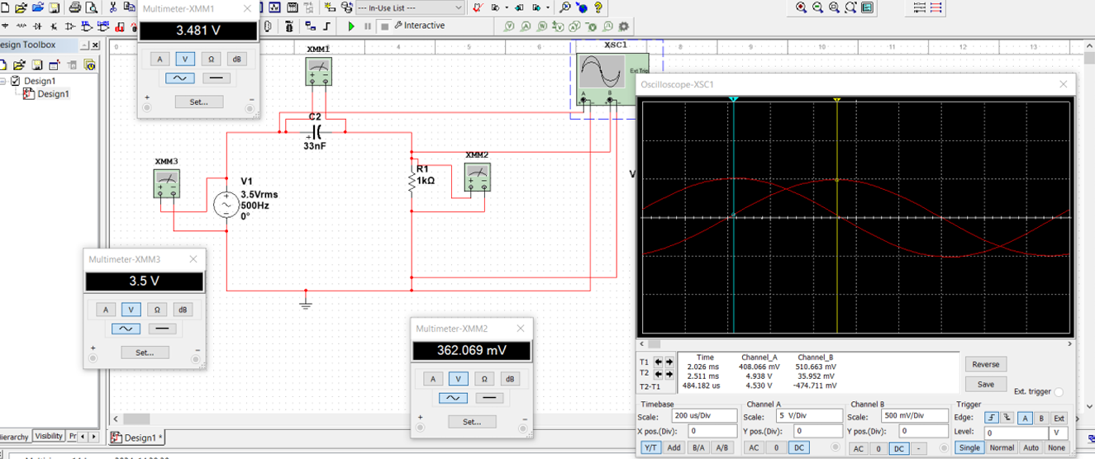

**1K:**

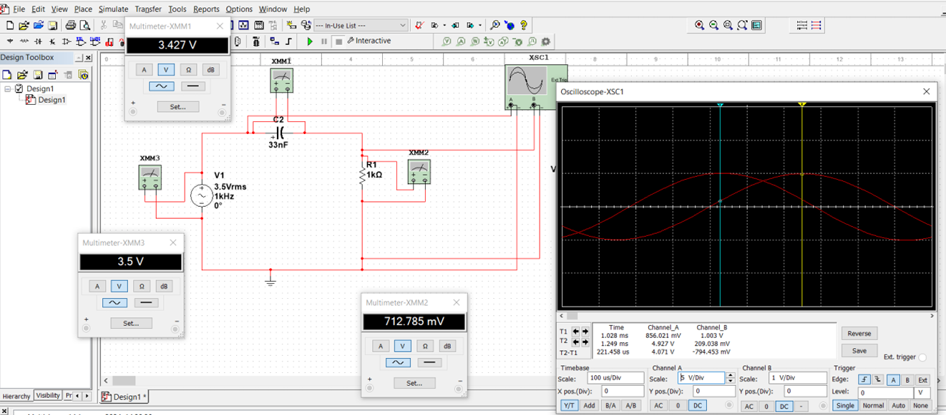

**2K:**

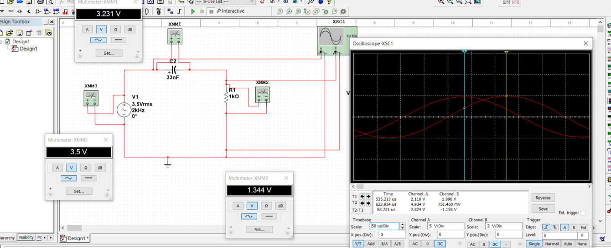

**5K:**

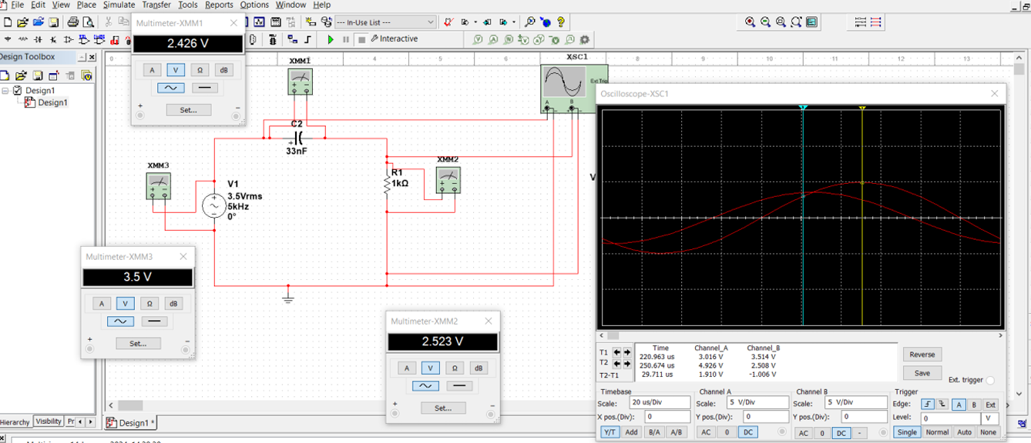

**10K:** 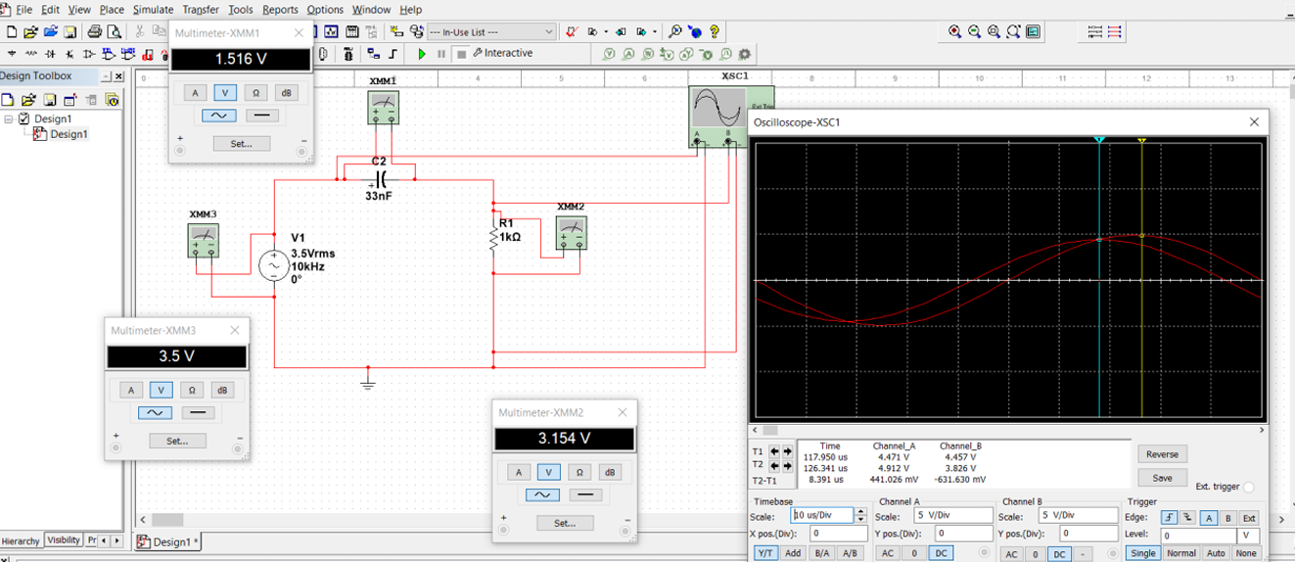

**20K:**

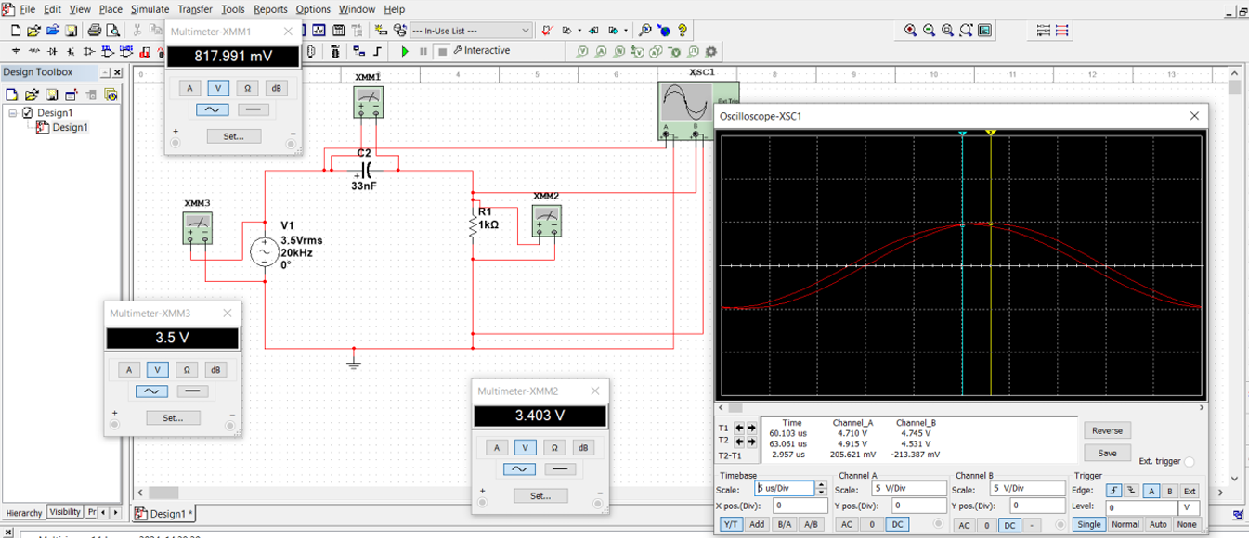

**30K:**

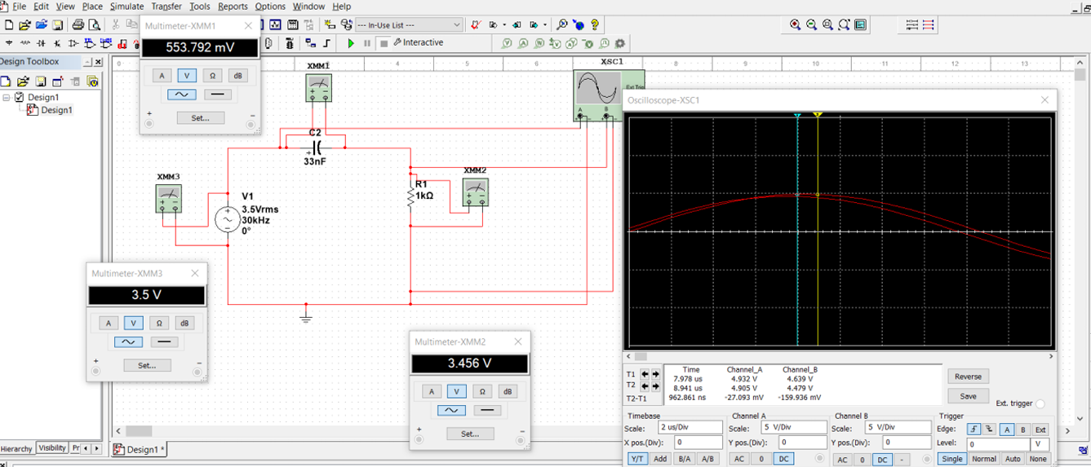

* 1. **Discuss the result in table 2 and support your answer by drawing VOUT (t).**

**As we see in the table 2 : as we increase the frequency Vr increase and Vc decrease ,**

**So, we concluded that frequency is inversely proportional to capacitor voltage according to the relation**

**Xc=1/2πfc,**

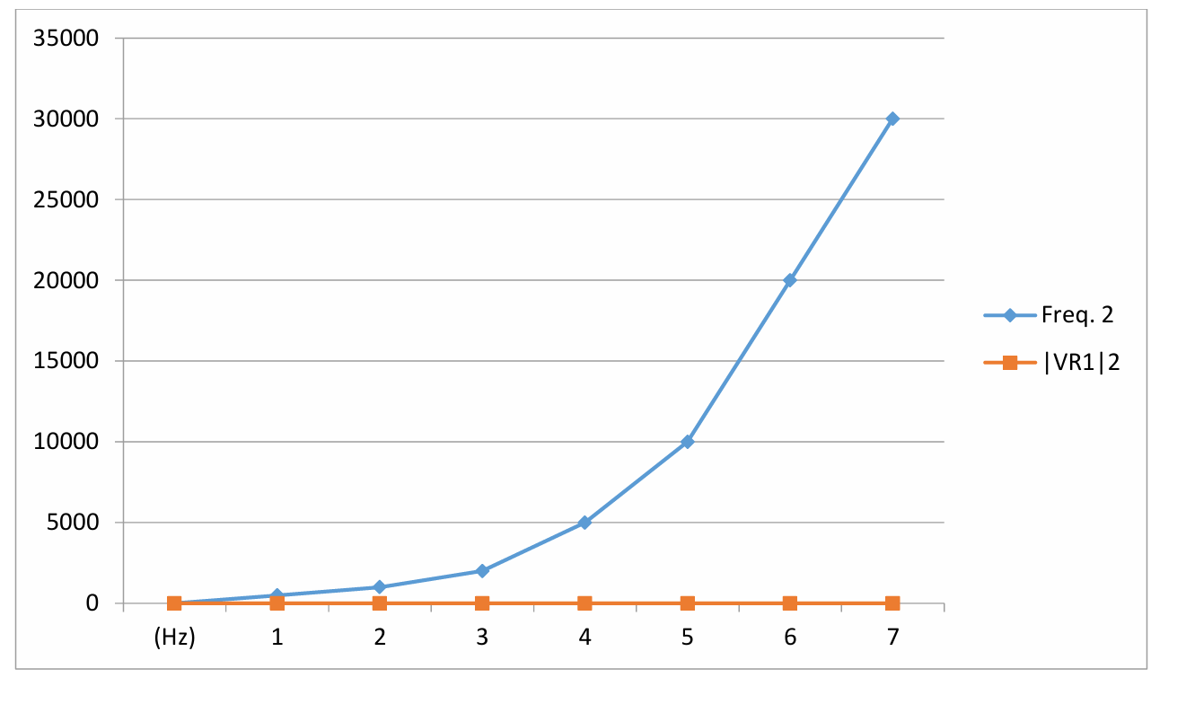

**And as it shown in the multisim photos, so VR increase and Vc decrease so vin remain the same value**

***Conclusion and Analysis:***

* Make a plot of |VC1/VIN| and |VR1/VIN| versus frequency for the collected data.

|  |  |  |
| --- | --- | --- |
| frequancy | |VC1/VIN| | |VR1/VIN| |
| 500 | **1** | **0.109** |
| 1000 | **0.98** | **0.23** |
| 2000 | **0.92** | **0.41** |
| 5000 | **0.69** | **0.75** |
| 10000 | **0.43** | **0.92** |
| 20000 | **0.23** | **0.99** |
| 30000 | **0.158** | **1** |

* Plot the phase between the source voltage and the circuit current as a function of frequency.

|  |  |
| --- | --- |
| frequancy | phase angle |
| 500 | 87.5 |
| 1000 | 85.4 |
| 2000 | 72.7 |
| 5000 | 56.16 |
| 10000 | 31.46 |
| 20000 | 12.6 |
| 30000 | 8.1 |

* Compare the measured phase difference for the calculated RC phase angles and the actual value.

|  |  |  |  |
| --- | --- | --- | --- |
| **Freq.**  **(Hz)** | **Ө**  **By Multisim** | **Ө**  **on Lab** | **|Ө By Multisim - Ө on Lab|** |
| **500** | **87.5** | 81 | 6.5 |
| **1k** | **85.4** | 73.4 | 12.5 |
| **2k** | **72.7** | 65.1 | 7.6 |
| **5k** | **56.16** | 40.4 | 15.76 |
| **10k** | **31.46** | 24.7 | 6.76 |
| **20k** | **12.6** | 12.7 | 0.1 |
| **30k** | **8.1** | 8.321 | 0.22 |